IMMUNE SYSTEM & WOUND HEALING & CELLS AND PROTEINS

**What are antibodies and antigens?**

An antigen is anything that makes the body sick. Examples are:

* Virus
* Fungus
* Bacteria
* Helminth
* Protozoan

An antibody is the molecule that marks a specific antigen. Antibodies are specific to each antigen.

**What is the main difference between the two subsystems of the immune system (innate and adaptive)?**

The innate immune system is preprogrammed to fight things it recognizes as an antigen.

The adaptive immune system can keep a memory of new antigens and learn how to fight them specifically for the future.

**What are the cells and types of molecules in each of the two subsystems? What do they do and when do they do it?**

**Phagocytosis (eating):** Large molecules or cells passing into a larger cell through the plasma membrane (skin).

**Protease:** An enzyme that breaks down proteins

Innate:

* Neutrophils
  + Arrives first
  + Consumes the antigen through phagocytosis.
  + Breaks down the antigen with proteases.
* Macrophages
  + Arrives second
  + Consumes the antigen through phagocytosis.
  + **??**An antigen presenting cell (slide 12)

Adaptive:

* B Lymphocytes (B cells)
  + Find antigens and mark them as targets
  + B cells are triggered by contact with antigens
  + B cell eats antigen through phagocytosis
  + B cell multiplies containing memory of antigen as “memory B-cells”
* T Lymphocytes (T cells)
  + Destroy the antigens marked by the B-cells

**What are the types of transport that occur across the plasma membrane of cells?**

**Diffusion:** Stuff moving through a wall

* Passive diffusion: Material passing from an area of high concentration into an area of low concentration (natural, E.g. Osmosis)
* Facilitated diffusion: Specific materials passing through the cell skin through holes in the skin made specifically for that material
* Active transport: Material being forced from an area of low concentration into an area of high concentration (not natural, opposite of passive diffusion, costs energy for the cell)
* Bulk transport: Transport of a **large** molecule or object into the cell using many mechanism (example: phagocytosis)

**What is extravasation?**

Basically *leaking*. In terms of the body, when fluids (e.g. blood) leaks into the body where it should not go.

**What is the difference between the two types of cell death?**

Aging a natural death of a cell which is pre-programmed into the cell when it is created. This is called apoptosis. If cells did not kill themselves you would get cancer.

Necrosis is unnatural death of a cell caused by trauma (physical damage), infection (virus / bacteria), or toxins (poison). Also looks really gross.

**Describe the timeline of immune cell response and wound healing.**

**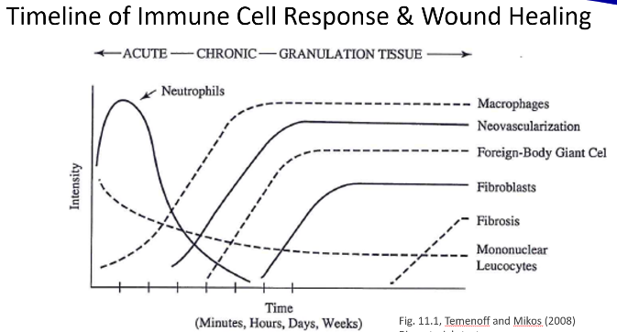***REAL ANSWER:*

Slide 39 of Immune System and Wound Healing -----------🡪

*MY ANSWER:*

* Start with innate system, comes and uses its cells to check new objects
* Will destroy them automatically if they are detected as bad objects
* Next, adaptive immune system B-Cells come
* If they are new and carry an antigen, the B-Cells eat them to gain a memory of them, generating Plasma cells.
* Plasma cells tag antigens that it recognizes with antibodies.
* T-Cells detect objects marked with antibodies and DESTROYS THEM.

**??Biomaterials-Tissue interaction and device-associated complications (graphic)**

**What is the difference between acute and chronic inflammation?**

Acute inflammation is short-term and usually a direct result of the body trying to recover from an injury or disease.

Chronic inflammation is long-term and usually is a result of a lifestyle (bad eating, no exercise, etc.) or genetic defect.

**What are the steps of the wound healing process?**

Not sure

BMEB SAFETY RULES & LAB TOUR

**Name types of PPE (Personal Protective Equipment).**

* Gloves
* Goggles (Safety Glasses)
* Lab coats

**What are the rules on the use of gloves?**

* Never re-use ***LATEX***gloves
* Make sure the material of the glove is resistant to permeation (going through) by the substance being handles
* Remove gloves before handling normal objects (computers, phones, etc…). Do not walk around with dirty gloves on both hands.
* Replace gloves periodically while working
* Do not throw gloves away in regular trash. Dispose in biohazard (dangerous poison) trash bins.

**Go through a chemical Safety Data Sheet.**

Example on Slide 17 of the lab safety PowerPoint.

**Where do you meet after exiting the building for a fire alarm?**

Spirit Park (by the stadium)

**Where are the fire alarms always located?**

Who knows??? I think the stairwell.

**What is the campus police phone number?**

257-4018

**What is the difference between a biosafety cabinet (cell culture hood) and a fume hood in terms of primary use and air flow patterns?**

Fume hoods are for protecting people from chemical fumes (gas). The fumes are vented outside where the dispersion of the gasses makes breathing it not a problem.

Biological Safety Cabinet/Cell Culture Hood is for working with bacteria or fungi in a controlled environment. Most of the air in it is recycled through a filter to protect the environment from your experiments, while the rest is vented outside.

PROTEIN INTERACTIONS WITH BIOMATERIALS AND SURFACE MODIFICATIONS, SURFACE CHARACTERIZATION, & POLYMER SYNTHESIS AND CONTACT ANGLE LABS

**Adsorption:** Protein sticking to surface of material

**Hydrophobicity:** How much a material dislikes water

**Hydrophilicity:** How much a material likes water

**Review protein properties and how those properties effect protein adsorption.**

* Size of protein: Larger proteins have more contact sites to stick with
* Charge of protein: More neutral proteins stick easier
* Hydrophobicity: More hydrophobic molecules like to stick to hydrophobic surfaces
* Structure:
  + Stability: Less stable proteins stick better due to unfolding more, increasing points to stick to.
  + Unfolding Rate: Molecules that unfold faster can form surface contacts more quickly.

**How do amino acid side chains affect protein structure?**

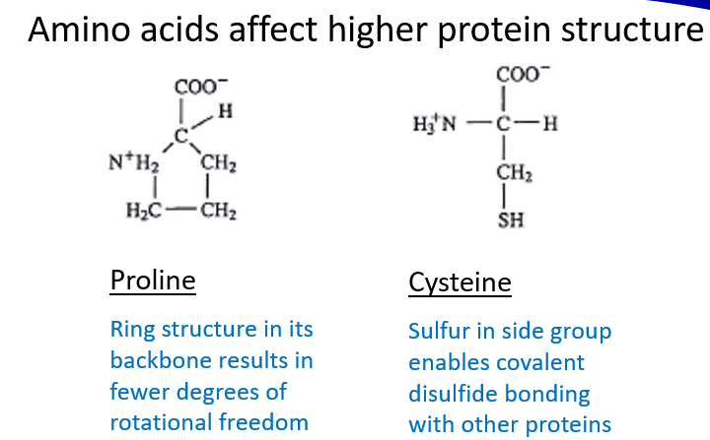Two ways: (see slide 9 of protein interactions & surface modifications PowerPoint)

1. Amino Acid prolines, which are basically rings of molecules on a protein, mean the protein cannot rotate as much
2. Amino Acid cysteines, which is an extra ion on the side, can allow bonding with other proteins. (Example in PowerPoint)

**What are the four levels of protein structure?**

1. Primary
2. Secondary
3. Tertiary
4. Quaternary

**Name common biopolymers.**

**Review the effect on adsorption of the Vroman effect and denatured and rearranged proteins.**

The Vroman effect says that given multiple proteins present in different concentrations, at first the protein in the higher concentration will be bound to the surface more, but eventually the different proteins will replace each other in descending order of highest concentration until the protein with the highest affinity for adsorption eventually replaces as the final adsorbed protein. Basically, the protein with the highest affinity will end with the highest concentration on the surface even if it doesn’t have the highest concentration overall.

Proteins can denature, or change shape and lose their energy, which can easily affect adsorption for a variety of reasons.

Rearranging proteins can do the same thing.

**Review the nature of the permanent layer on a surface.**

If many proteins form a layer on a surface and adsorb, they can become very hard to remove and sometimes eventually form actual covalent bonds.

**Review application of coatings meant to prevent protein adsorption and/or functional surfaces.**

One way to prevent unwanted proteins from adsorbing is to apply a coating of an inert chemical to stay in the middle.

**What are some types of functionalization of biomolecules?**

* Waterproofing
* Changing polarity
* Changing magnetism
* Changing rigidness / rotational freedom

**Review stimulus responsive polymers.**

Stimulus responsive polymers can change shape, size, and density based on some stimulus. Stimuli can be:

* A certain pH
* A certain temperature
* Electric / magnetic field

These changes are used to deliver drugs held in polymers, change the shape of an implant, pump fluids, etc.…

**Review devices for surface analysis.**

* Electron spectroscope

**Destructive and nondestructive testing.**

There are different ways to perform tests on materials. Some tests are destructive to the material and some are nondestructive.

A destructive test will destroy the material, like the tensile strength tests.

Nondestructive tests will not destroy the material.

**What are uses and concerns for contact angle measurement?**

Contact angle measurement tests are used to measure the wettability of material surface, which can be used to evaluate its hydrophilicity.

This method of testing has some flaws, because some unpredictable factors of the environment and the material being tested can result in a large variance in the angles measured for each material.

**Review tacticity, crystallinity, crosslinking, and other structural characteristics.**

*From how I understand what Google tells me:*

Tacticity: The effect of large molecular patterns on the movability of a polymer chain.

Crystallinity: The degree of order in a molecular structure.

Crosslinking: Linking two polymer chains together with covalent or ionic bonds.

**Review the different types of biological polymers.**

* Nucleic acids
* Proteins
* Polysaccarides

**What are viscoelastic properties and what causes them on a molecular/chain level?**

Viscoelastic properties are those that exhibit both viscous and elastic characteristics. Simply, a viscoelastic material is both runny and stretchy. The important point is that viscoelastic materials exhibit something called time-dependent strain, which is where deformations that happen “too fast” are recovered, but changes that happen slowly are permanent.

Viscoelastic properties are caused by bonds that resist increase in velocity in materials where those same forces cause elastic responses in molecules.

MECHANICAL PROPERTIES

**Review effects of other mechanical properties on tensile properties of polymers.**

Tensile properties are how a material will react at varying levels of stress and strain.

Tensile properties can change depending on the structure and makeup of a material, like:

* Temperature
* Crystallinity
* Cross-sectional area

**Tensile vs. shear stress measurements**

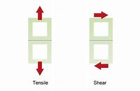Two types of stress:

1. Tensile stress is applied perpendicular to a surface.
   1. Calculated as Force / Cross-sectional area
2. Shear stress is applied parallel to a surface.
   1. Calculated as Force / Area of surface

**Endurance measurements**

*I think…*

By endurance, what is meant is the maximum stress a material can take, such as Ultimate Tensile strength, and endurance limit, which is how many “cycles” of stress is required for a material to fail.

**Review tables of material properties.**

Slide 10 on Mechanical Properties PowerPoint.

Orthopedic implants and reactions

**Bone is an anisotropic composite biological material.**

* Anisotropic means its physical properties, like strength, are different depending on which direction you measure in
* Composite means it has features of multiple material types (ceramic, metal, polymer…)

**Know the cell types.**

**What are the major biopolymers in bone?**

Collagen

Bone Crystals

**What are the main minerals in bone?**

Calcium, Phosphorus, and magnesium

**How do the last two contribute to dynamic properties of bone?**

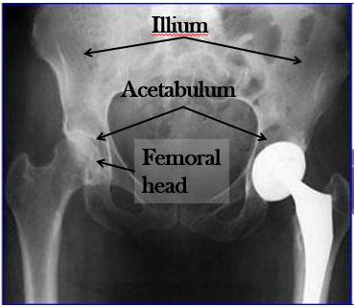Crystal structures cause differences in stress reactions depending on the direction relative to the molecular structure.

**Review hip anatomy:**

* **Ilium**
* **Acetabulum**
* 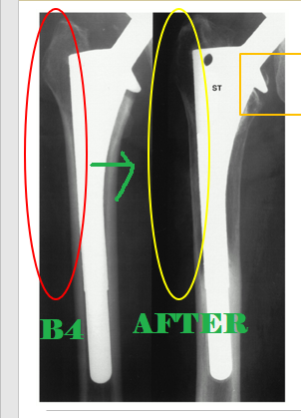**Femoral head**
* **Etc.**

**What are major causes of hip implant failure? Not including breakage and squeaking.**

Stress shielding, where the implant supports most of the stress of supporting the weight of the person, causes the surrounding bone to weaken. --------------------🡪

Osteolysis, which is where the polyethylene from the implant can grind off from rubbing against the bone. The immune system will attack these free pieces of the implant, which can weaken the bone and loosen the implant, causing it to fail.

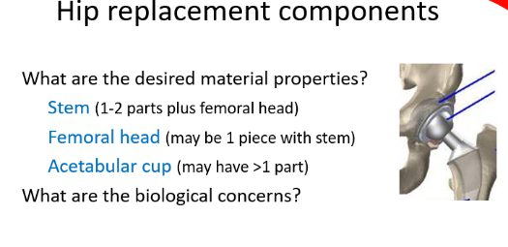**Name the three major components of a total hip implant.**

Stem

Femoral Head

Acetabular cup

**Name some types of materials used in these implants.**

* CoCr (Cobalt-Copper) alloys and Ti (Titanium) alloys
* Ceramics
* Polymers (UHMWPE)
* Bone cement

**STUDY QUIZZES AND ASSIGNMENTS 1 & 2**

**Textbook is only needed to study when it was needed to answer a homework question.**

**Class and lab notes are important.**